**DEPARTMENT OF COMPUTER SCIENCE**

**VEER NARMAD SOUTH GUJARAT UNIVERSITY, SURAT**

**PROJECT REPORT**

**AS A PARTIAL REQUIREMENT**

**FOR THE DEGREE OF**

**MASTER OF COMPUTER APPLICATION**

**(MCA 4th SEMESTER)**

**YEAR- 2018-19**

**AMC Management System**

**Guide: Students Name:**

**Mr.Utsav Patel Bagde Vishal G.**

**ORGANIZATION**

**U & V TRADING**

**SACHIN**

**Certificate**

This is to certify that the project entitled **AMC MANAGEMENT SYSTEM** has been submitted by **BAGDE VISHAL G.** towards partial fulfillment of requirement for 4th semester of Masters Of Computer Application[M.C.A] for the academic year **2018-19**.She has carried out the project work for **U & V Trading**

**Yours Truly,**

**Mr.Utsav Patel**

Signature Stamp of Firm

Acknowledgement

Any small or big project is not possible without the moral support of many people. Apart from the efforts of myself, the success of any project depends largely on the encouragement and guidelines of many others. I take this opportunity to express my gratitude to the people who have been instrumental in the successful completion of this project.

I was able to do my project with full concentration due to professional and responsive surrounding of the firm.

I am deeply grateful to **Dr.Apurva Desai** (Director In charge of Department of Computer Science) for his valuable advice and guidelines for systematic approach towards the work.

I would also like to thank **Mr.Utsav Patel** for his assistance for providing me the opportunity to develop their organization system for **“U & V Trading”** .The guidance and support received from all the members who contributed and who are contributing to this project, was vital for the success of the project. I am grateful for their constant support and help.

Yours Sincerely,

Bagde Vishal G

**INDEX**

|  |  |  |
| --- | --- | --- |
| Sr. No. | Topics | Page No. |
| 1) | **Introduction** | 5 |
|  | * 1. Personal Profile | 5 |
|  | * 1. Company Profile | 6 |
| 2) | **Project Category** | 7 |
|  | 2.1) Technologies  2.2) About Project | 7  9 |
| 3) | **Tools & Environment Used** | 10 |
|  | * Tools(H/W & S/W specification) | 10 |
| 4) | **Project Analysis Report** | 11 |
|  | 4.1) Data Flow Diagram | 11 |
|  | 4.2) Database Design | 17 |
| 5) | **Design Report** | 23 |
|  | 5.1) Screen Layout | 24 |
|  | 1. System | 25 |
|  | 1. TPS and MIS Report | 32 |
| 6) | **Future Enhancement** | 41 |
| 7) | **References** | 42 |

**-: PART 1:-**

**Introduction:**

**1.1) Personal Profile:**

* **Name** : Mr. Bagde Vishal G.

* **Class**  : S.Y.M.C.A (SEM 4)
* **Roll No** : 06
* **COLLEGE**  : DEPARTMENT OF COMPUTER SCIENCE
* **UNIVERSIT**Y : Veer Narmad South Gujarat University
* **PROJECT TITLE** : AMC MANAGEMENT SYSTEM
* **COMPANY PROFILE** : U & V Trading

**1.2) Company Profile**

|  |  |
| --- | --- |
| COMPANY NAME | CONTACT DETAIL |
| **U & V Trading**  **Add. 2667,Sahyog Society,Gujarat Housing Board,Kanakpur ,sachin-304230** | **Email id:**  [**unvtrade@gmail.com**](mailto:unvtrade@gmail.com)  **Cellular:**  **+91-8460787561**  **+91-8347080002** |

**-: PART 2 :-**

**Project Category:**

2.1)**Technologies:**

* **Front-End :**



**Visual Studio 2015**

**Programming Language:** – vb.net

* **Back-End :**



**Database :** SQL Server

* **REPORT:**



SAP Crystal Report

**2.2)About Project**

The project name is AMC Management System. This system issued in managing various activity of firm. It includes many modules, listing:

Customer management, AMC, service and complain Management. Management of various modules viewing, insertion, updating and deletion of specific records.

The goal of system are useful for daily maintain of customer contract and complain Maintain .

There’s also have a functionality of report generation and some of MIS Reports.

**Features**

Dynamic Dashboard

Customer Module

Annual Maintenance Contract Module

AMC Service

Customer Complain

Customer Payment

**-: PART 3:-**

**Tools & Environment used:**

**- (H/W & S/W used along with purpose):**

a) Hardware Specification:

* Processor Intel Core i3
* Ram 4 GB
* Minimum Space Required 1GB
* Display 64bit color

b) Software Specification:

* Operating Environment 64 Bit,

Windows 10

* Platform –Visual Studio 2015 and above
* SQL Server

c) Other Tools:

* EDraw

**-: PART 4 :-**

**Project Analysis Report:**

**4.1) DFD (DATA FLOW DIAGRAM):**

|  |
| --- |
| **CONTEXT LEVEL** |

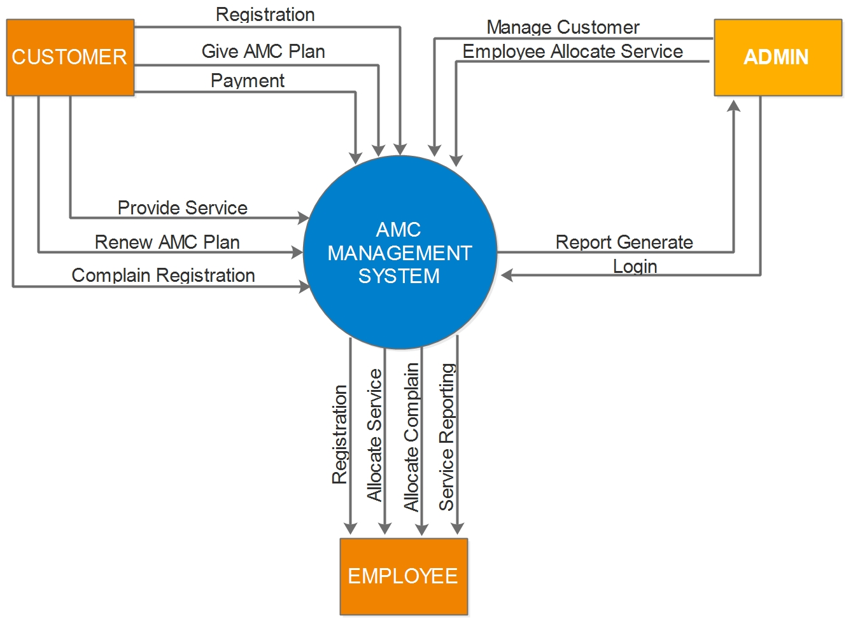

|  |
| --- |
| **1ST LEVEL DFD OF AMC Management System** |

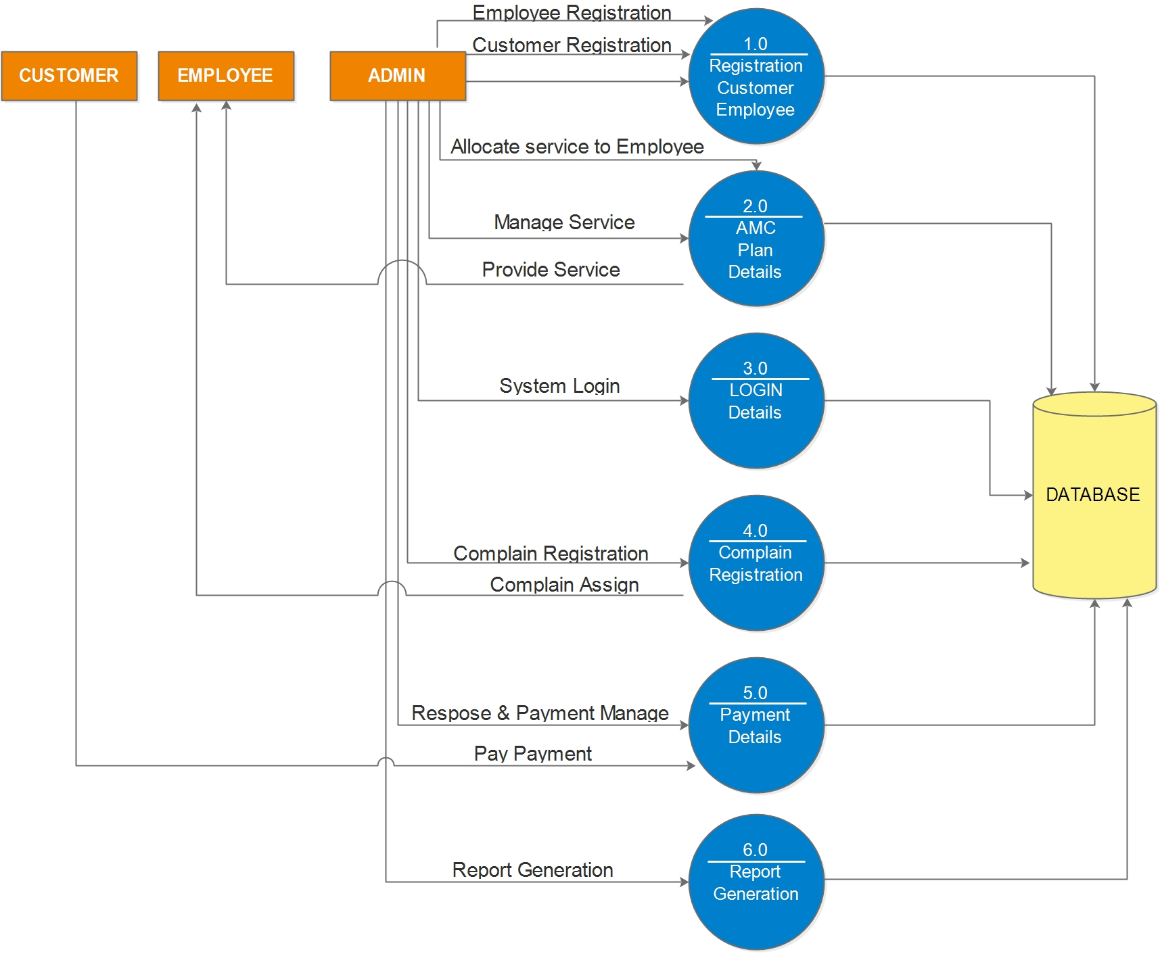

|  |
| --- |
| **2nd  LEVEL DFD OF Registration Details** |

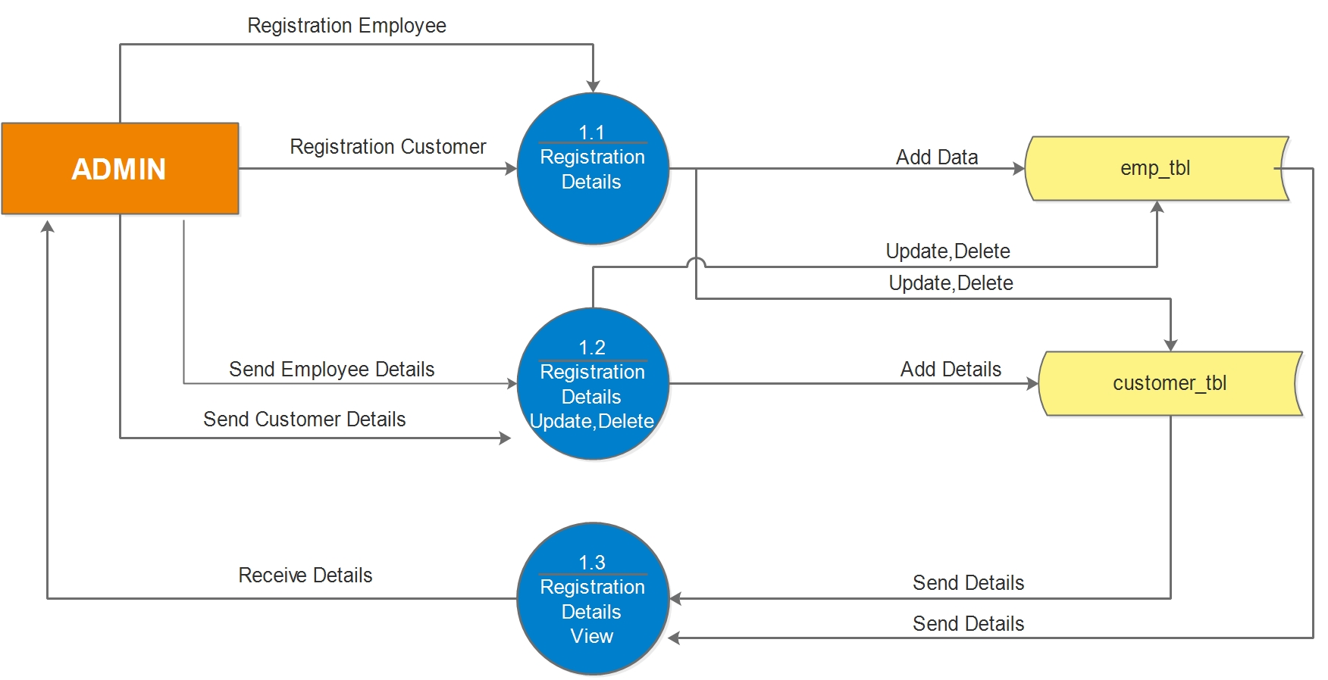

|  |
| --- |
| **2nd  LEVEL OF DFD of AMC Plan** |

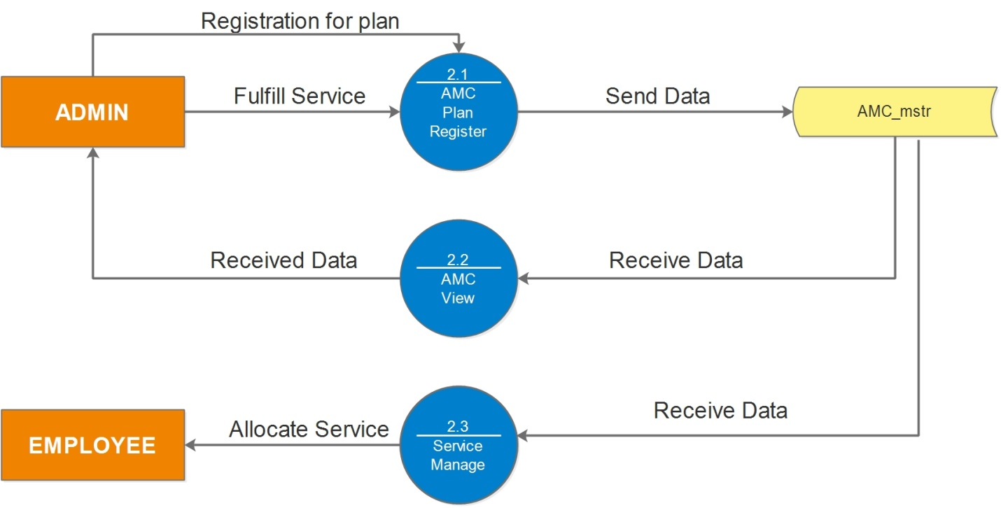

|  |
| --- |
| ­­­­**2nd  LEVEL OF DFD of Login Detail** |

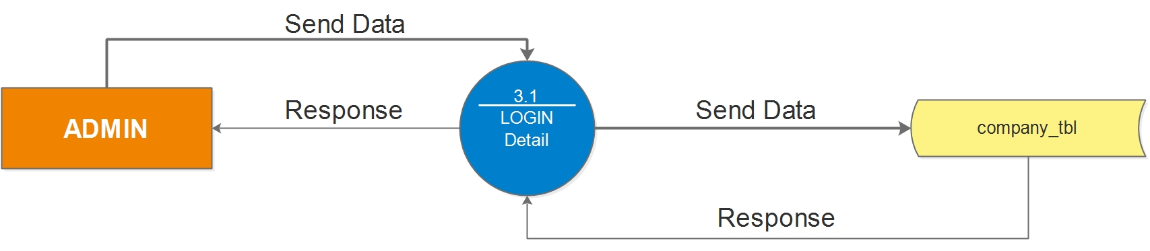

|  |
| --- |
| **2nd  LEVEL OF DFD of Complain Management** |

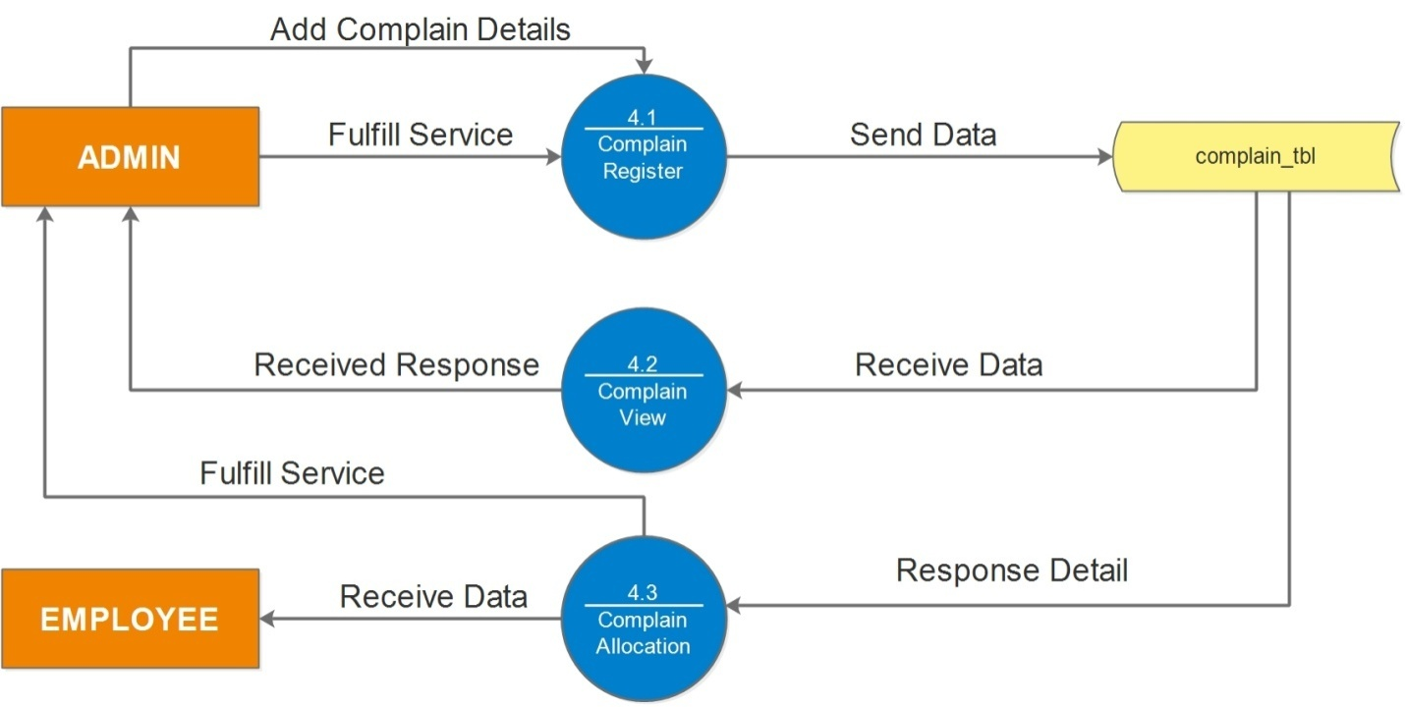

|  |
| --- |
| **2nd  ­­LEVEL OF DFD of Payment Details** |

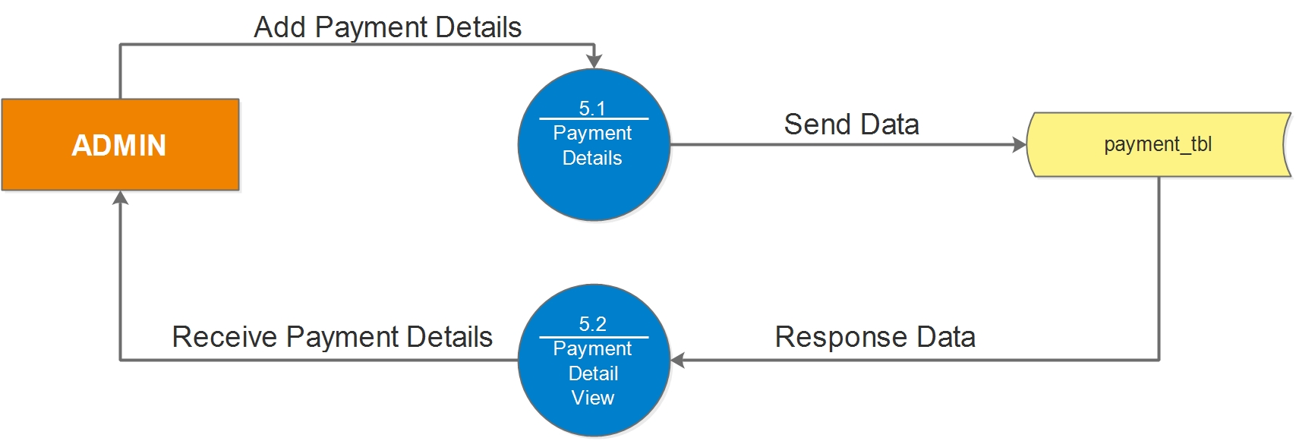

**4.2) Database Design**

|  |  |  |  |  |
| --- | --- | --- | --- | --- |
| **customer_tbl** | | | | |
| **Sr. No.** | **Field Name** | **Data type** | **Constraint** | **Description** |
| 1 | customer_id | int | Primary Key(AI) | Unique Customer id |
| 2 | customer_name | nvarchar(25) | Not Null | Customer Name |
| 3 | Address | nvarchar(30) | Not Null | Customer address |
| 4 | Area_name | nvarchar(15) | Not Null | Area name |
| 5 | City_id | int | Not Null | Reference in city_mstr |
| 6 | Pincode_id | int | Not Null | Refererence in Pincode_mstr |
| 7 | Phone_r | nvarchar(11) | Not Null | Phone number |
| 8 | Phone_m | nvarchar(11) | Not Null | Mobile number |
| 9 | Email | nvarchar(25) | Not Null | Customer email |
| 10 | Remark | nvarchar(50) | Not Null | Customer remark |
| 11 | Status | nvarchar(30) | Not Null | Customer status(active,deactive) |
|  | Entry_date | date | Allow nulls |  |

|  |  |  |  |  |
| --- | --- | --- | --- | --- |
| **Pincode_mstr** | | | | |
| **Sr. No.** | **Field Name** | **Data type** | **Constraint** | **Description** |
| 1 | Pincode_id | int | Primary Key(AI) | Pincode id is unique |
| 2 | Pincode_name | nvarchar(30) | Not Null | Pincode name |
|  | Status | nvarchar(25) | Not null | Status (active,deactive) |

|  |  |  |  |  |
| --- | --- | --- | --- | --- |
| **City_mstr** | | | | |
| **Sr. No.** | **Field Name** | **Data type** | **Constraint** | **Description** |
| 1 | City_id | int | Primary Key(AI) | City id |
| 2 | City_name | nvarchar(30) | Not Null | City name |
| 3 | Pincode_id | int | Not Null | Reference Pincode id |
| 4 | Status | nvarchar(20) | Not Null | Pincode status(active,deactive) |

|  |  |  |  |  |  |  |  |
| --- | --- | --- | --- | --- | --- | --- | --- |
| **Category_mstr** | | | | | | | |
| **Sr. No.** | **Field Name** | | **Data type** | | **Constraint** | | **Description** |
| 1 | Category_id | | int | | PrimaryKey | | Category_id |
| 2 | Category_name | | nvarchar(30) | | Not Null | | Category_name |
| 3 | Status | | nvarchar(30) | | Not Null | | Status |
| **Product_mstr** | | | | | | | | |
| **Sr. No.** | **Field Name** | **Data type** | | **Constraint** | | **Description** | | |
| 1 | Product_id | int | | Primary Key | | Product id | | |
| 2 | Product_name | nvarchar(30) | | Not null | | Product name | | |
| 3 | Category_id | int | | Reference Key | | Reference to category | | |
| 4 | Status | nvarchar(12) | | Not Null | | Product status | | |

|  |  |  |  |  |
| --- | --- | --- | --- | --- |
| **Company_mstr** | | | | |
| **Sr. No.** | **Field Name** | **Data type** | **Constraint** | **Description** |
| 1 | Company_name | nvarchar(30) | Not null | Company name |
| 2 | Address | nvarchar(30) | Not Null | Company address |
| 3 | Phone_r | nvarchar(11) | Not null | Phone number |
| 4 | Email | nvarchar(30) | Not null | Company email |
| 5 | Website | nvarchar(25) | Not Null | Company website |

|  |  |  |  |  |
| --- | --- | --- | --- | --- |
| **Amc_mstr** | | | | |
| **Sr. No.** | **Field Name** | **Data type** | **Constraint** | **Description** |
| 1 | Amc_id | int | Primary key | Amc id |
| 2 | Amc_name | nvarchar(30) | Not null | Amc name |
| 3 | Amc_type | nvarchar(30) | Not Null | Amc type (PAID,FREE) |
| 4 | Price | Int |  | Amc price |
| 5 | N_of_Service | Int | Not Null | How many service in amc |
| 6 | Remark | nvarchar(30) | Not Null | Amc remark |
| 7 | Service_year | Int | Not Null | How many year to provide service |
| 8 | Status | nvarchar(30) | Not Null | Amc status(active,deactive) |

|  |  |  |  |  |
| --- | --- | --- | --- | --- |
| **Contract_tbl** | | | | |
| **Sr. No.** | **Field Name** | **Data type** | **Constraint** | **Description** |
| 1 | Contract_id | int | Primary Key(AI) | Contract id |
| 2 | Customer_id | int | Reference key | In customer_tbl |
| 3 | Machine_name | nvarchar(30) | Not Null | Customer machine name |
| 4 | Model_no | nvarchar(30) | Not null | Machine model number |
| 5 | Serial no | nvarchar(30) | Allow null | Machine serial number |
| 6 | Brand | nvarchar(30) | Allow null | Machine brand |
| 7 | Contract_date | date | Not null | Contract date |
| 8 | From_period | date | Not null | Contract from period |
| 9 | To_period | date | Not null | To period |
| 10 | Sales_by | int | Reference key | In emp_mstr |
| 11 | sales_amt | Int | Not null | Amc Sales amt |

|  |  |  |  |  |
| --- | --- | --- | --- | --- |
| **Service_tbl** | | | | |
| **Sr. No.** | **Field Name** | **Data type** | **Constraint** | **Description** |
| 1 | Service_id | Int | Primary Key | Service id |
| 2 | Contract_id | Int | Reference Key | Reference to contract_tbl |
| 3 | Service_date | Date | Not Null | Service date |
| 4 | Service_status | nvarchar(30) | Not Null | Service status (pending,allocated,resolve) |

|  |  |  |  |  |
| --- | --- | --- | --- | --- |
| **Complain_tbl** | | | | |
| **Sr. No.** | **Field Name** | **Data type** | **Constraint** | **Description** |
| 1 | Complain_id | int | Primary Key | Complain id |
| 2 | Customer_id | Int | Not Null | Reference to customer_tbl |
| 3 | Comp_date | Date | Not Null | Complain date |
| 4 | Complain_info | nvarchar(50) | Not Null | Complain information |
| 5 | Allocate_to | Int | Not Null | References to emp_mstr |
| 6 | Comp_status | nvarchar(20) | Not Null | Complain status(pending,allocated,resolved) |
| 7 | Work_info | nvarchar(50) | Not Null | Complain completion information |
| 8 | Amount_charge | Int | Not Null | Amount charge |

**-: PART 5:-**

**Design Report:**

**5.1) Screens Layouts**

**Main Page**

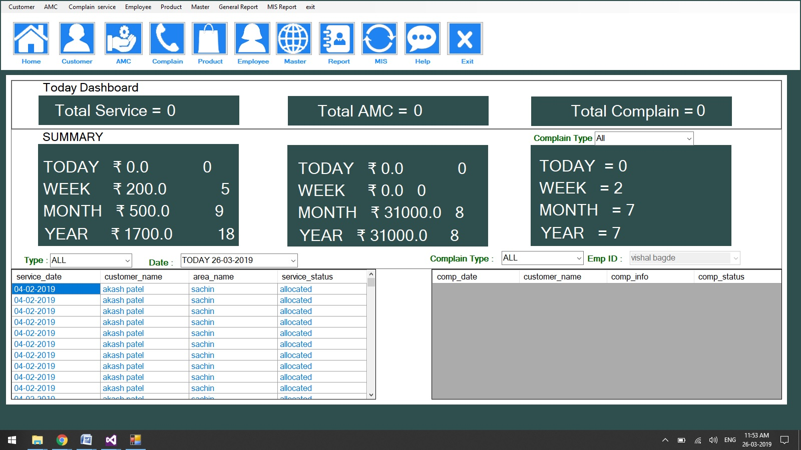

**Product Entry**

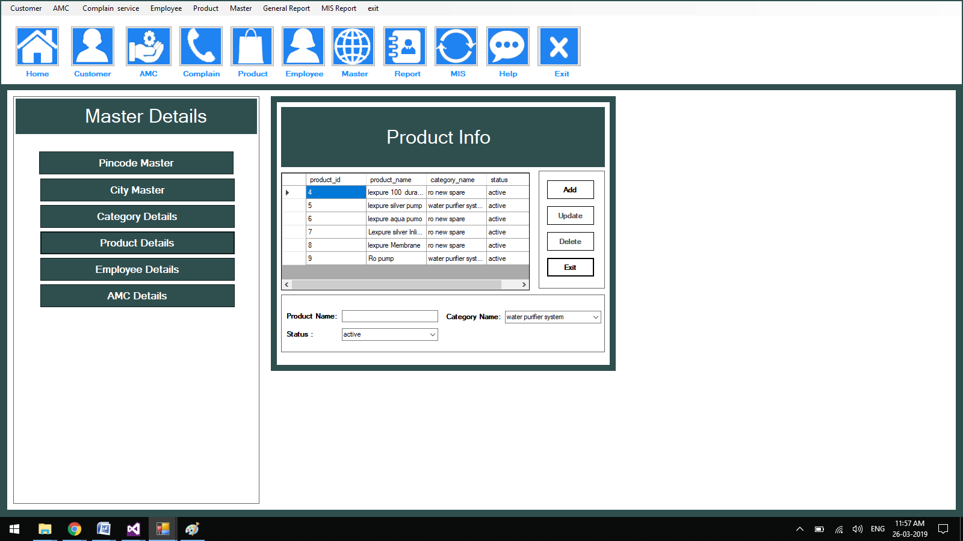

**Employee Entry**

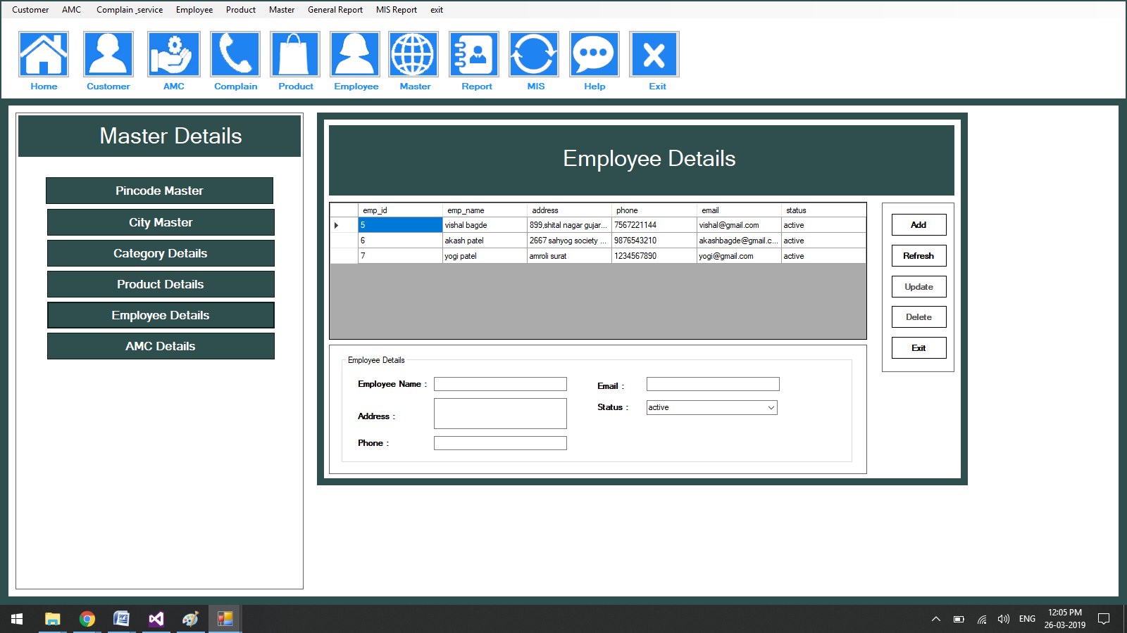

**AMC Entry**

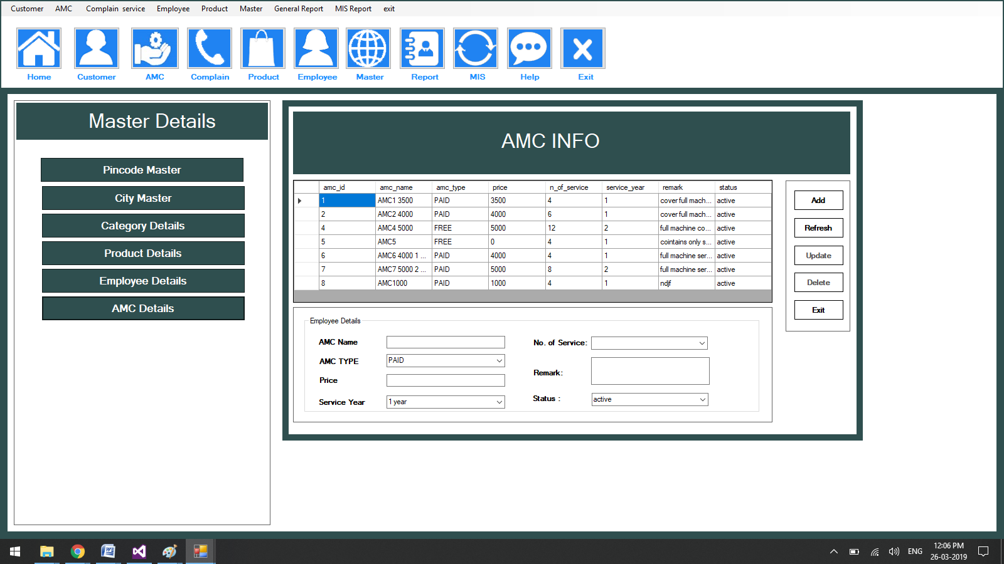

**Customer Entry**

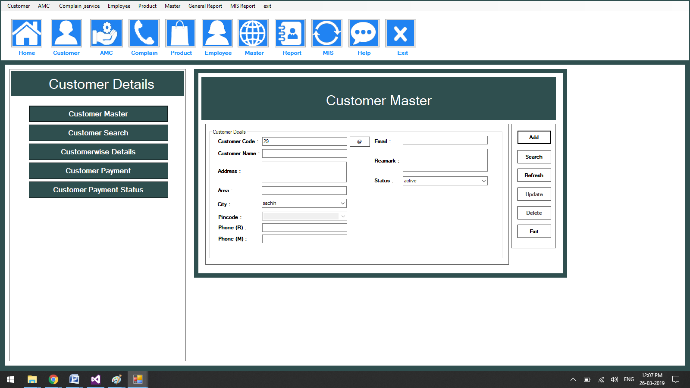

**Customer Payment**

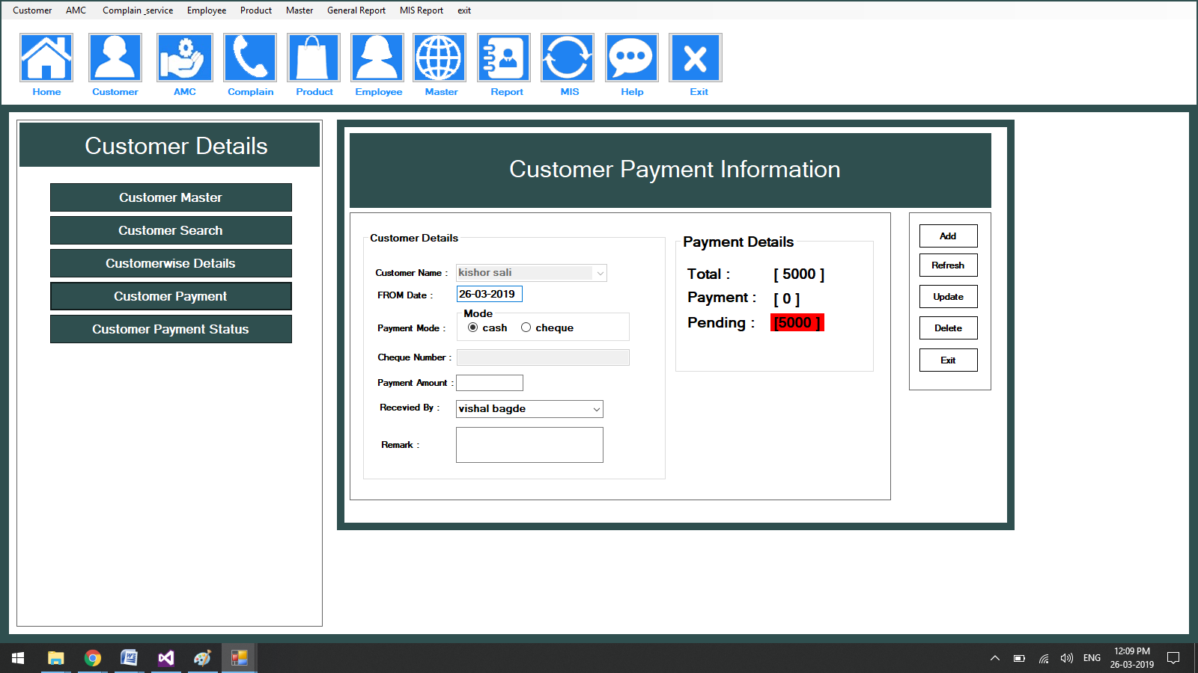

**Customer Payment Status**

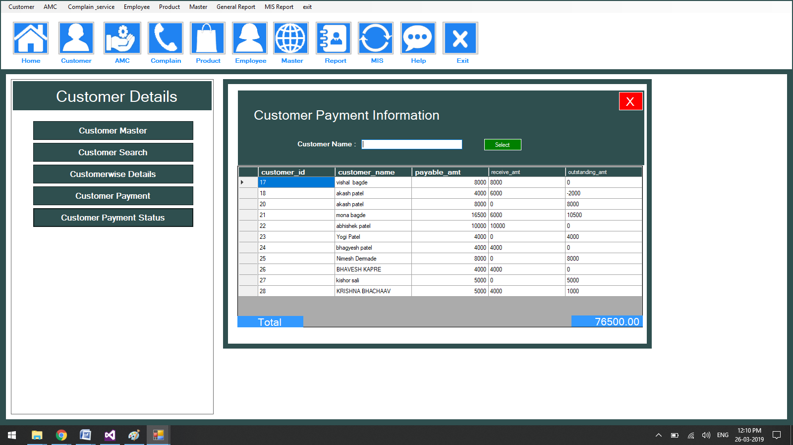

**Contract Entry**

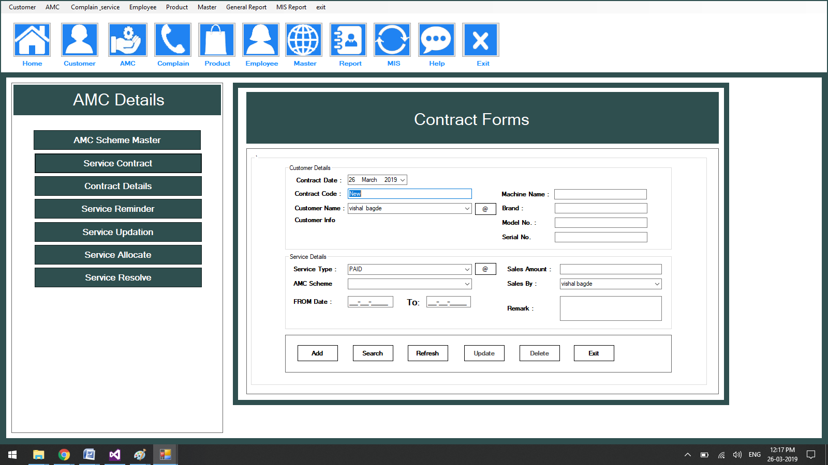

**Service Updation**

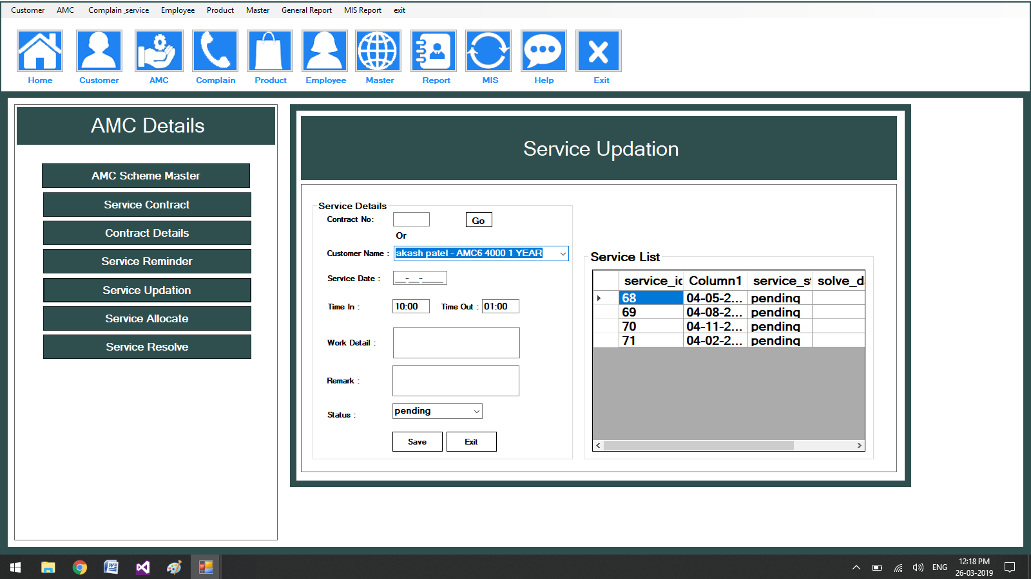

**Service Resolved Details**

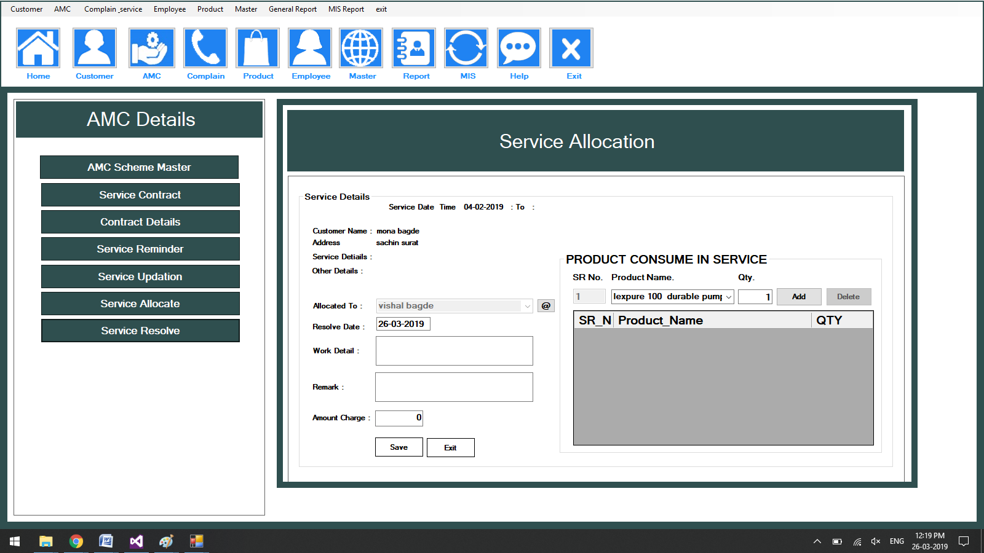

**Complain Entry**

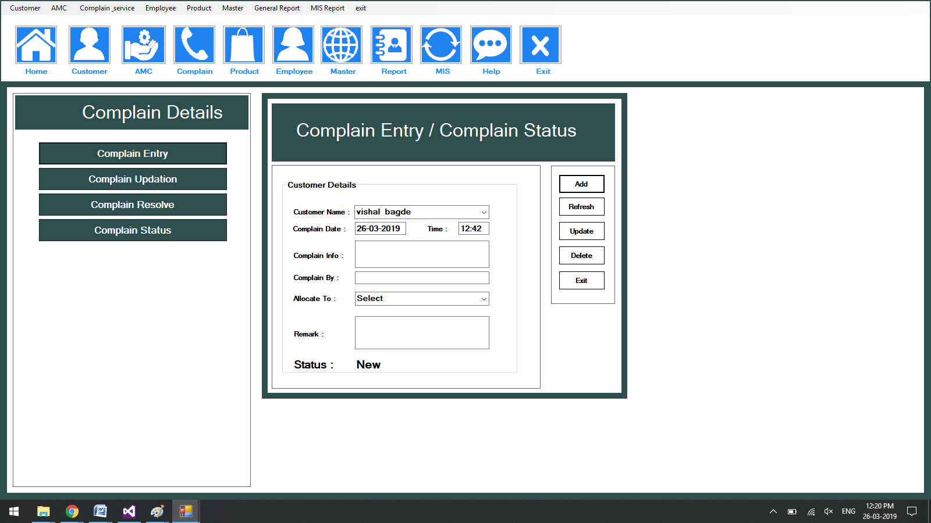

**Complain Status**

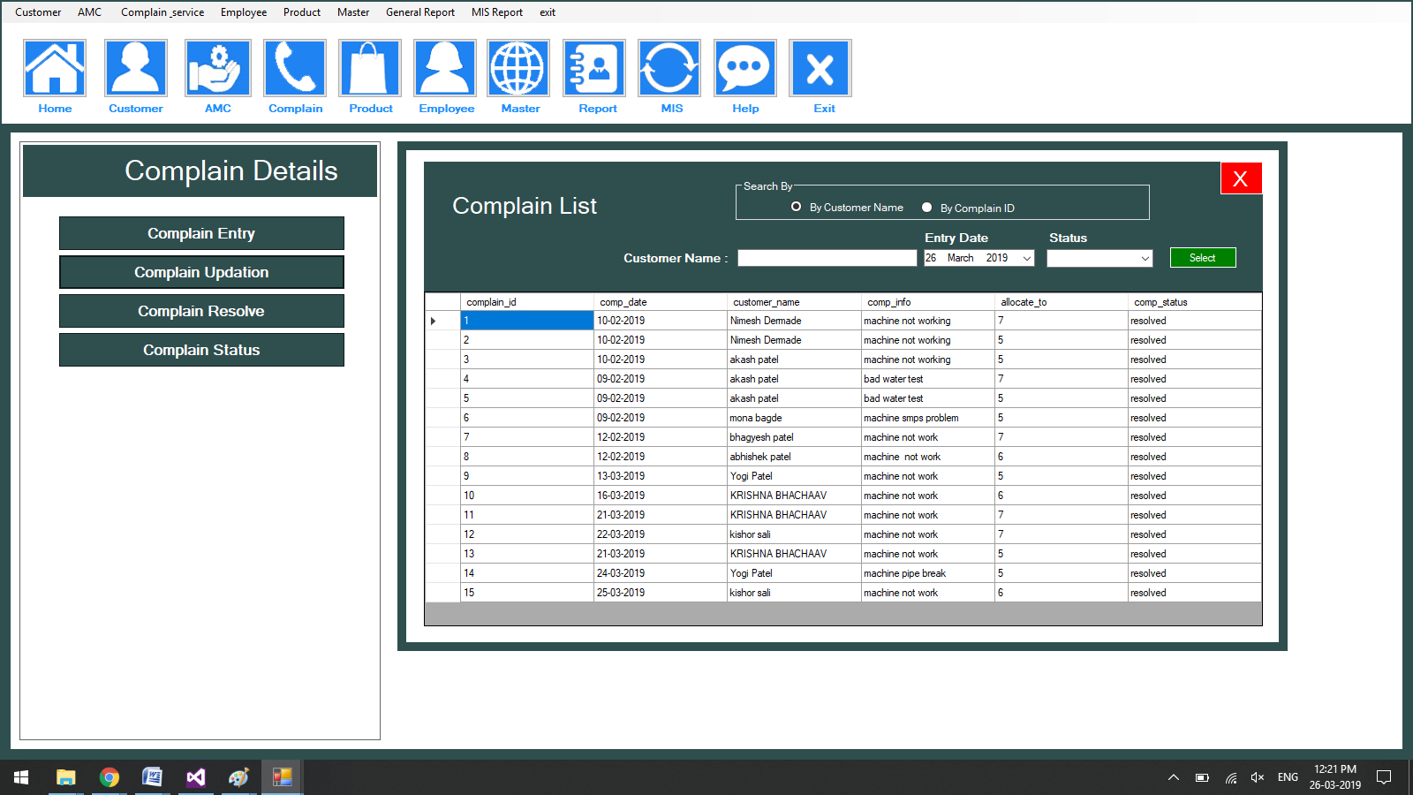

**Service Resolve Entry**

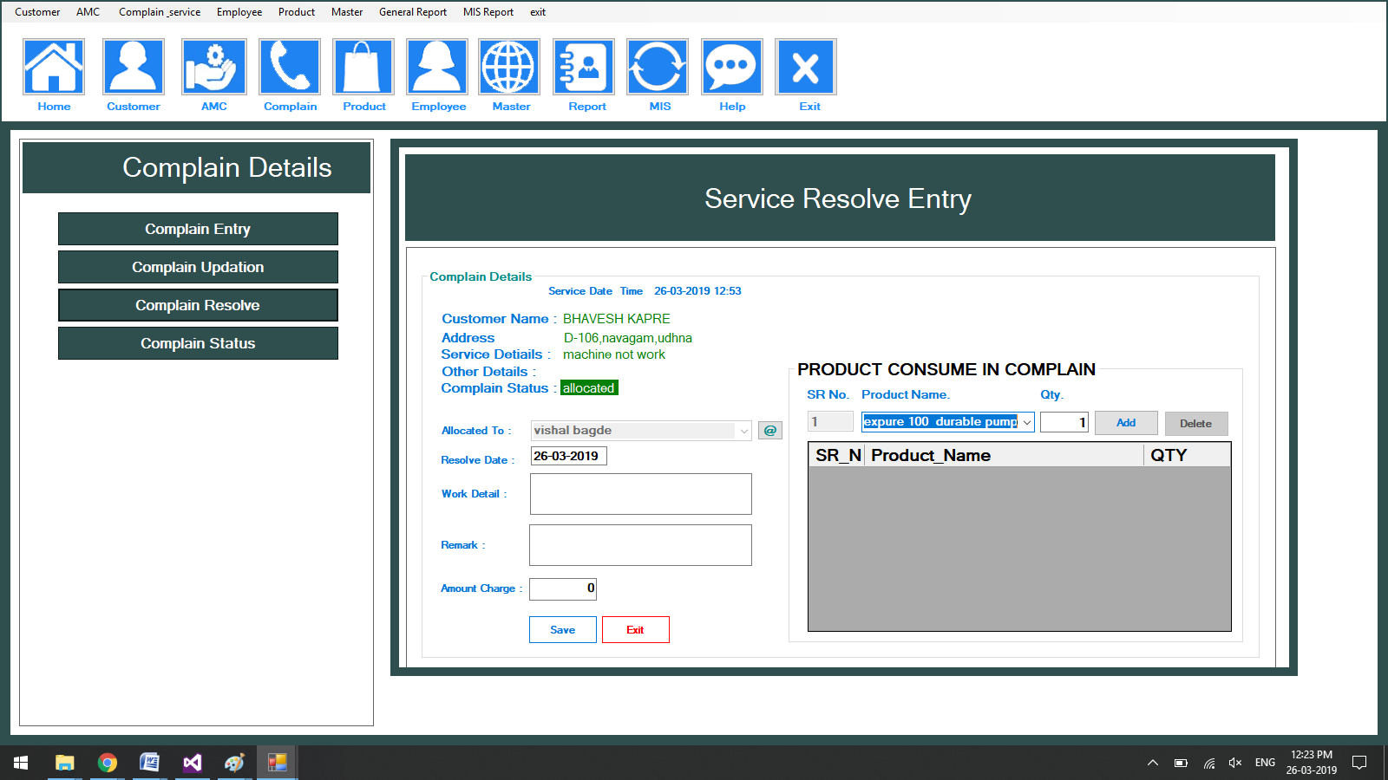

**TPS REPORT**

**Product Consume Report**

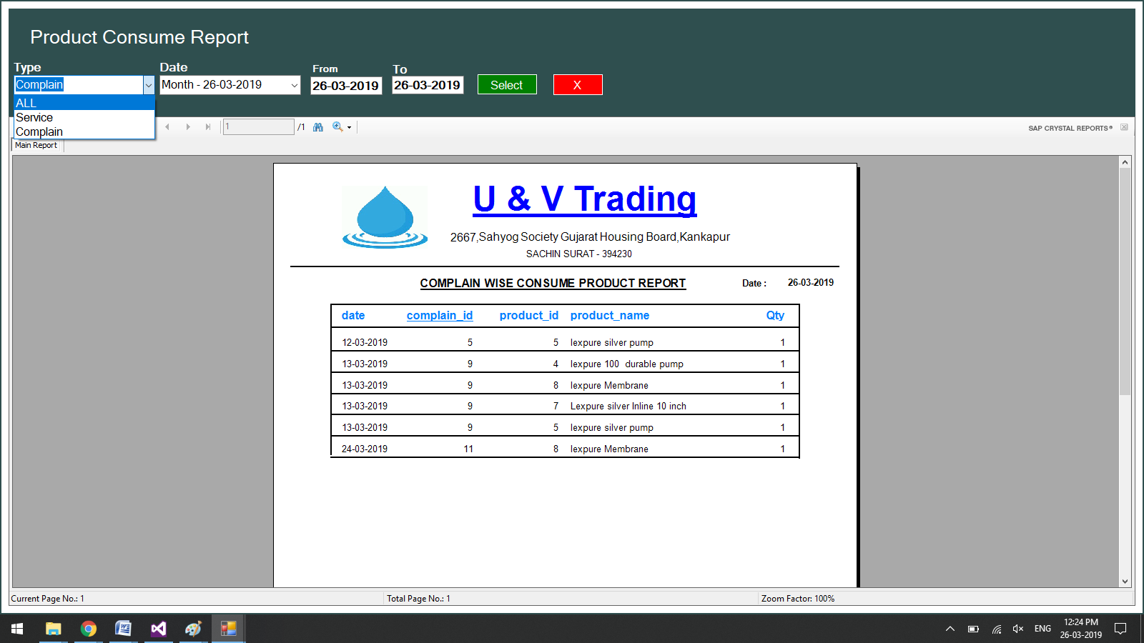

**Complain wise product Consume Report**

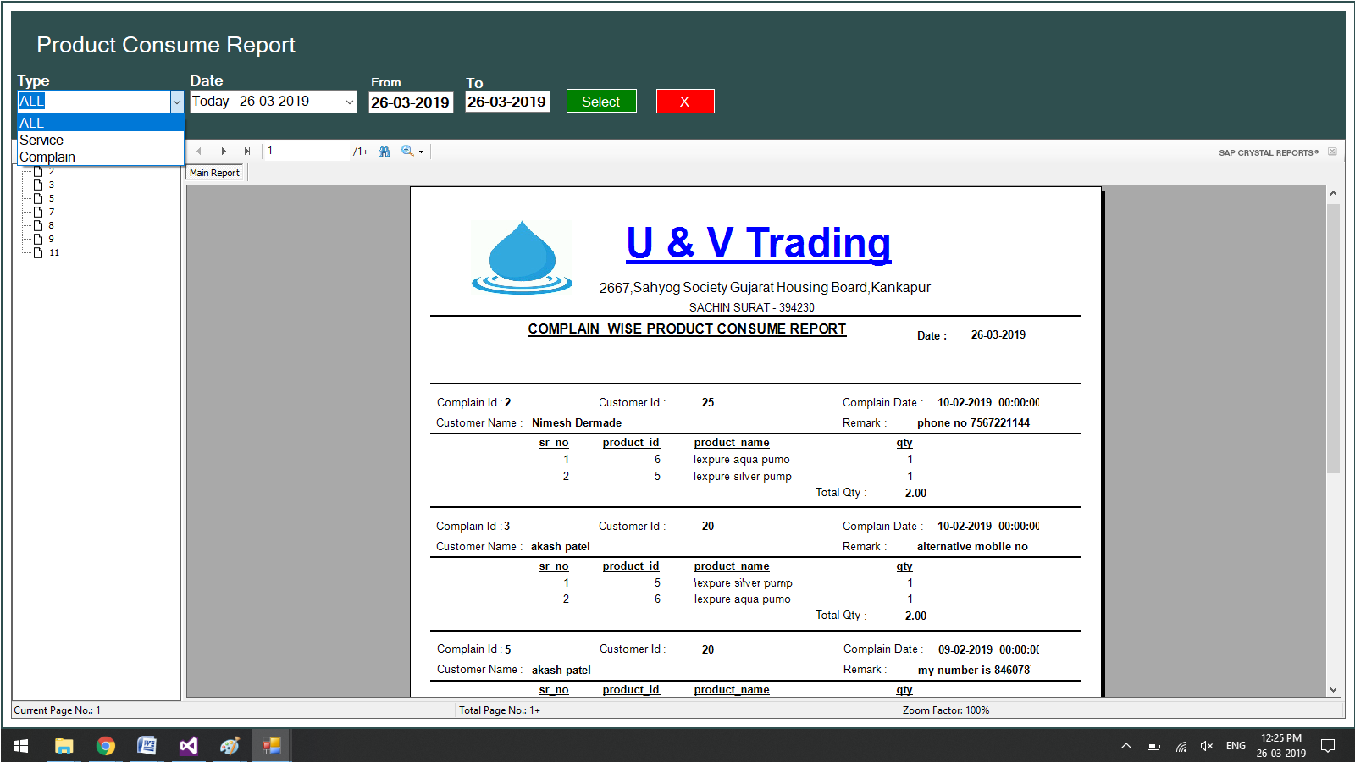

**Customer Details AMC wise**

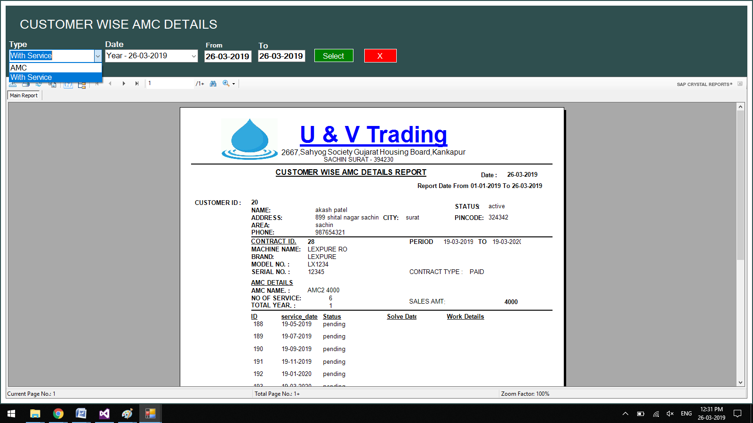

**AMC Sales Details**

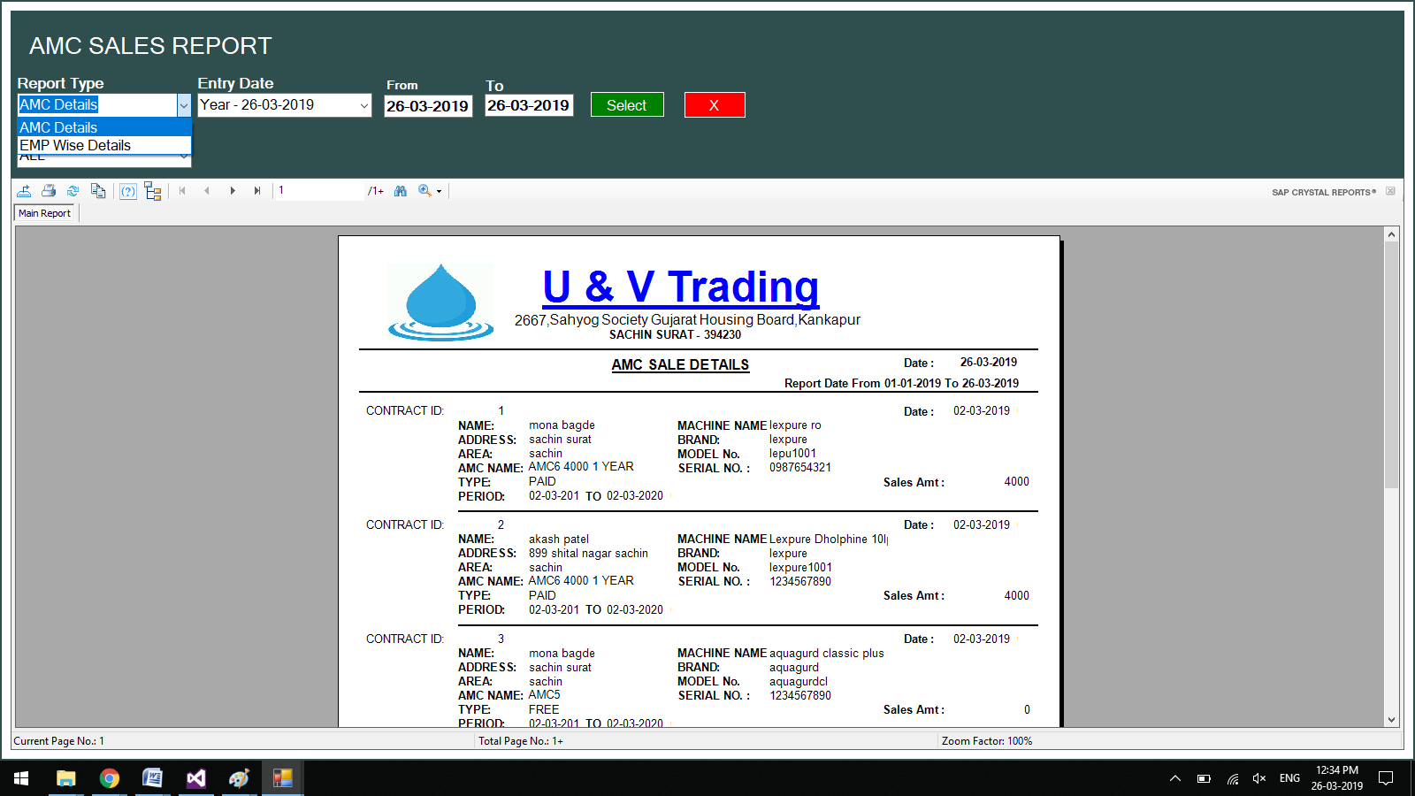

**Customer Complain Report**

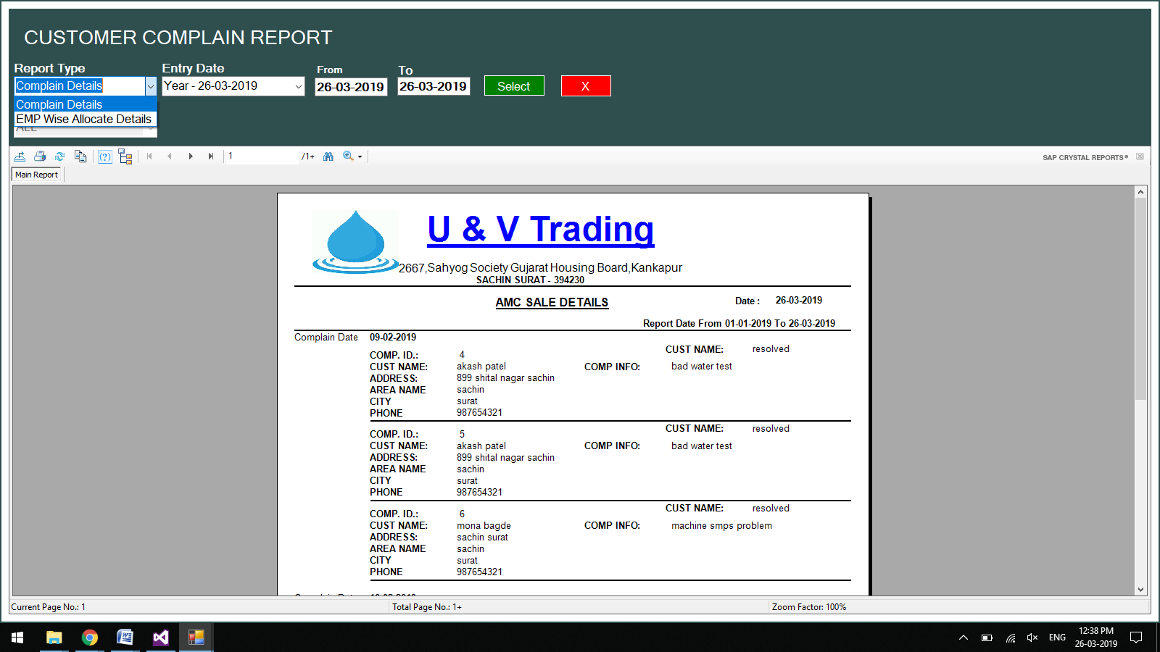

**Customer wise complain Allocation**

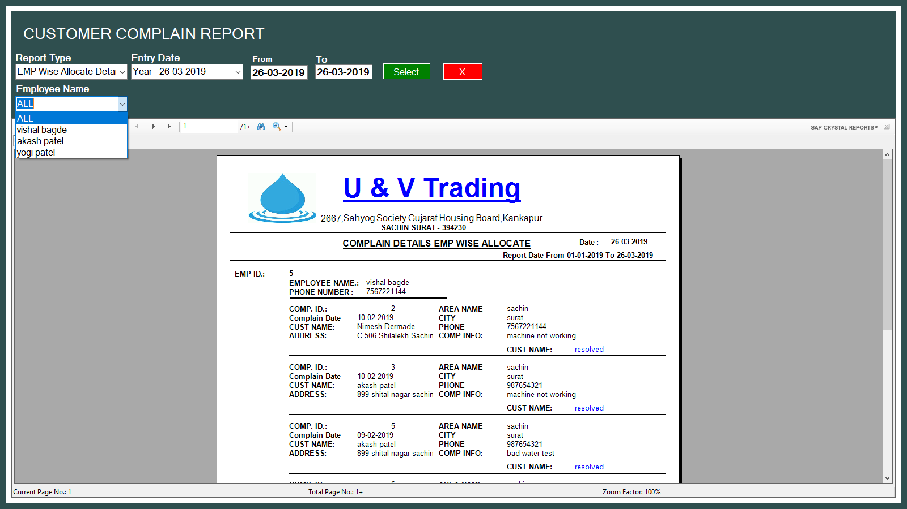

**MIS REPORT**

**Employee Wise same Day Resolve Service**

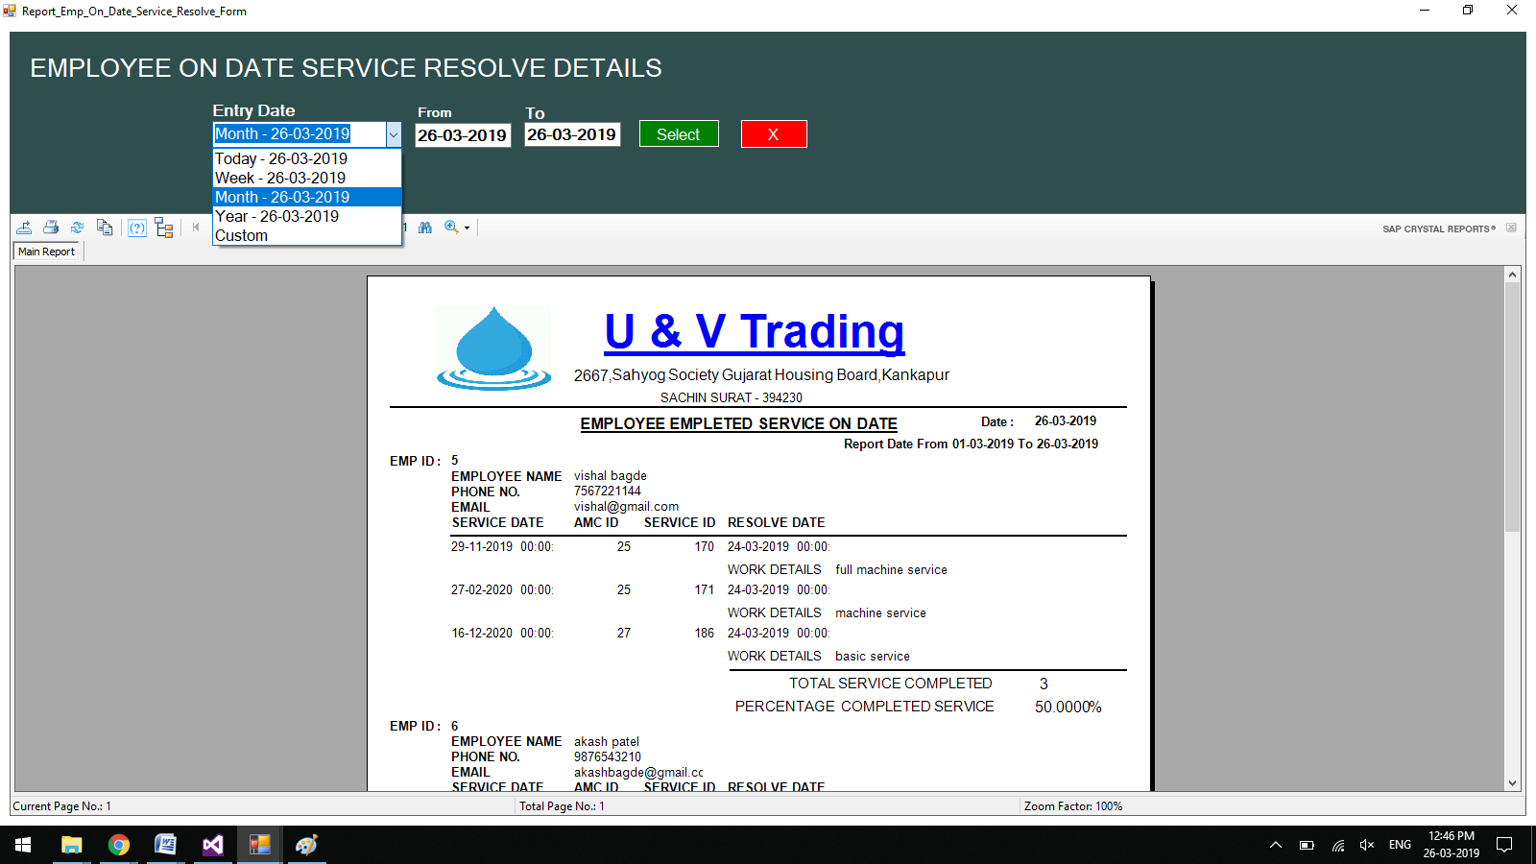

**City Wise AMC Sold**

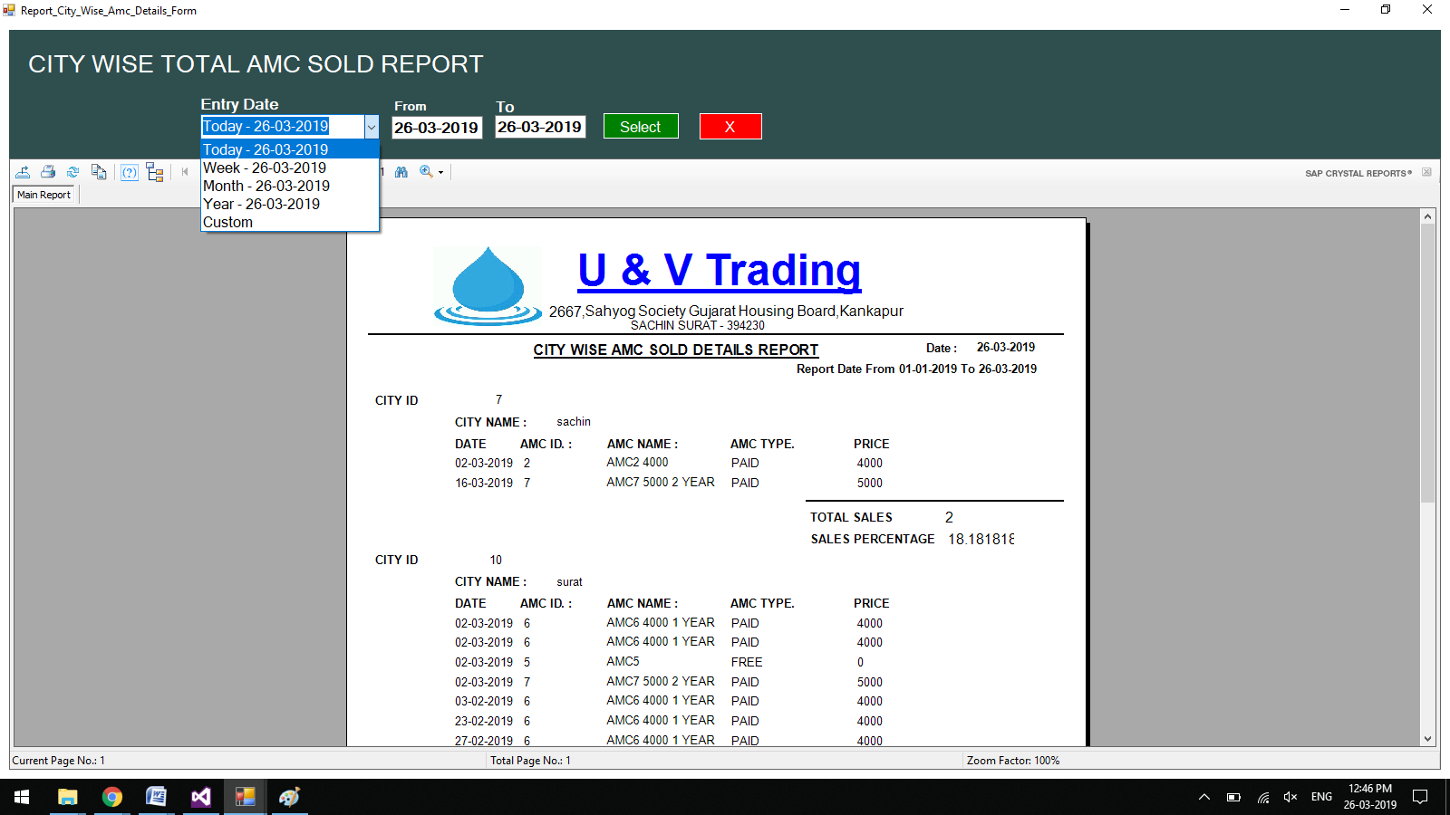

**Same Day Resolve Complain Report**

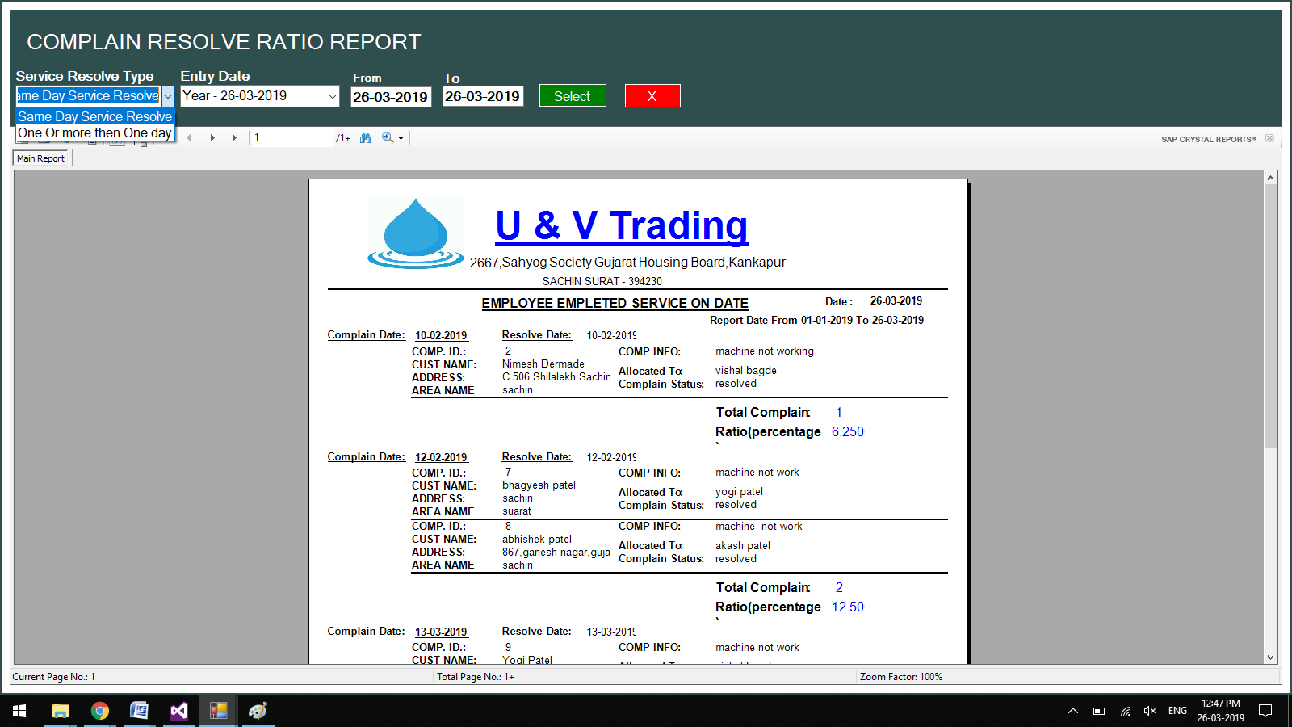

**6) Future Enhancement**

1. **Customer SMS Alert**
2. **Stock Management**
3. **AMC Renewal**

**7) References:**

* **Bibliography:**



[**www.edrawsoft.com**](http://www.edrawsoft.com)